Reflective Practice:
This diagram presents the stages in reflective practice, on the next page is a template for you to complete your own:

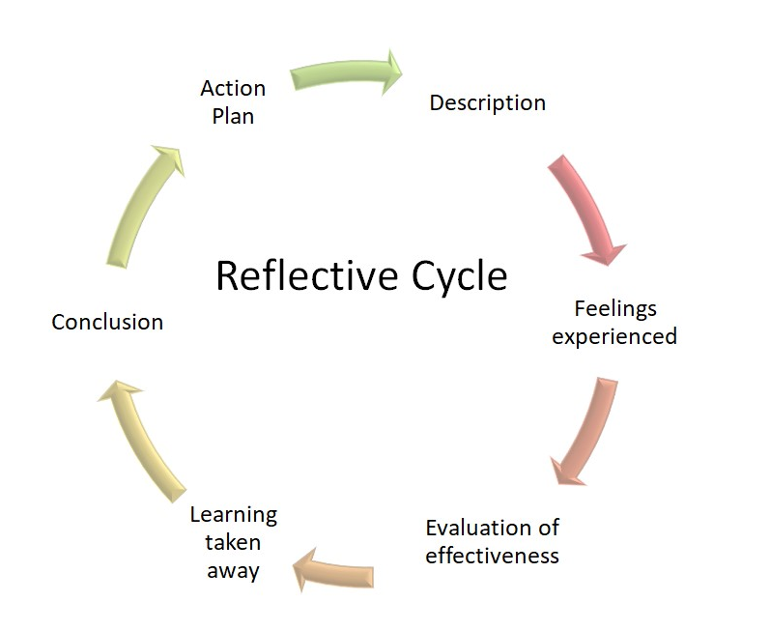

My Reflective Practice:
Date:
Issue for review (Event, action, conversation etc.) | Description:  (What happened?) | Feelings:  (What were you thinking and feeling throughout?) | Evaluation:  (What went well, what didn’t go well?) | Learning:  (In the same situation, what could I improve?) | Conclusion:  (What key lesson arises for me in general?) | Action Plan:  (In future, what should I seek to strengthen or change?)

